**Iteration 1**

Metrics Averaged

===========================

Avg Loss: 0.021029318543151022

Avg Mae: 0.06941553940996528

Avg Val_Loss: 0.007574854069389403

Avg Val_Mae: 0.051624897960573436

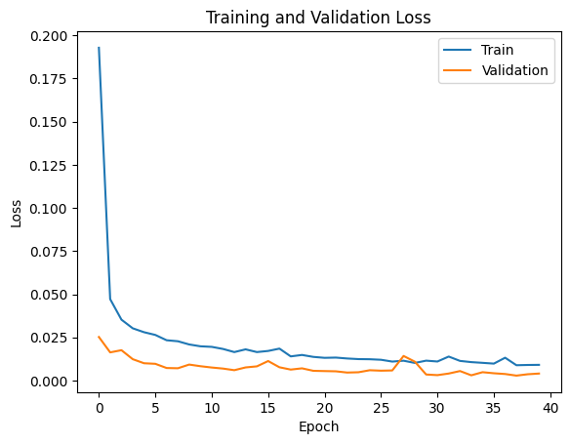

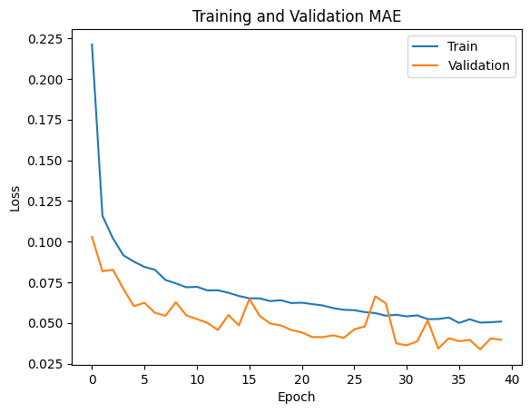

52/52 [==============================] - 0s 4ms/step

50/50 [==============================] - 0s 3ms/step

Validation RRMSE: 0.012483471905003155

Testing RRMSE: 0.05334552989367672

Final Evaluation on Test Data

52/52 [==============================] - 0s 2ms/step - loss: 0.0052 - mae: 0.0433

[0.005189647898077965, 0.0432930663228035]

Loss:0.005189647898077965

MAE:0.0432930663228035

**Iteration 2**

Metrics Averaged

===========================

Avg Loss: 0.023340756283141674

Avg Mae: 0.075110699608922

Avg Val_Loss: 0.010464094433700666

Avg Val_Mae: 0.05911568412557244

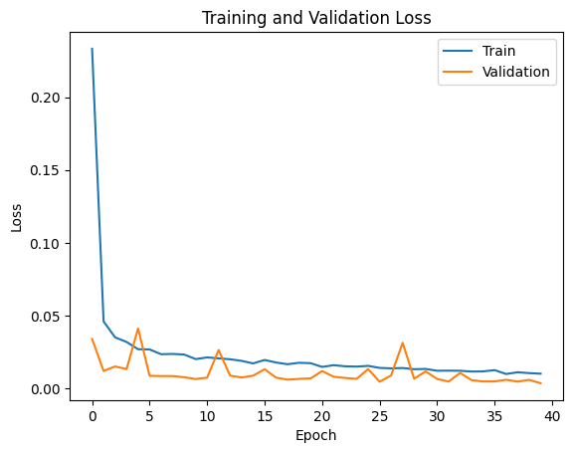

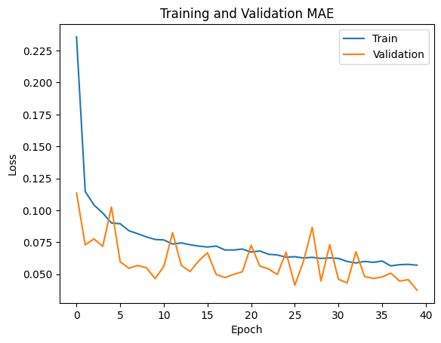

52/52 [==============================] - 0s 1ms/step

50/50 [==============================] - 0s 2ms/step

Validation RRMSE: 0.011575275258958406

Testing RRMSE: 0.0435050016257138

Final Evaluation on Test Data

52/52 [==============================] - 0s 1ms/step - loss: 0.0035 - mae: 0.0371

[0.0034515978768467903, 0.03714818134903908]

Loss:0.0034515978768467903

MAE:0.03714818134903908

**Iteration 3**

Metrics Averaged

===========================

Avg Loss: 0.023398020188324153

Avg Mae: 0.07742967950180173

Avg Val_Loss: 0.015554703265661374

Avg Val_Mae: 0.06854278361424804

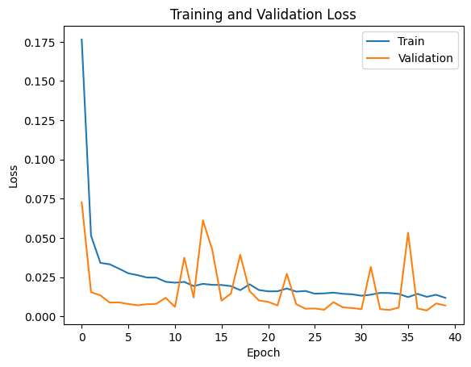

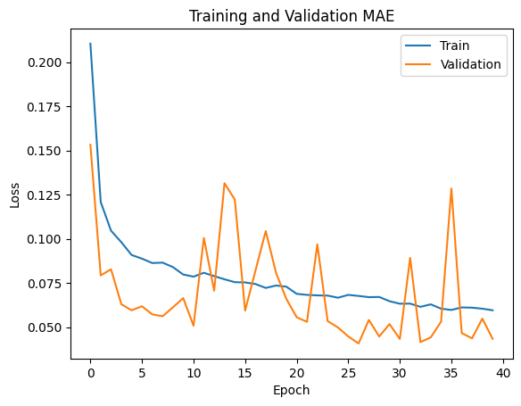

52/52 [==============================] - 0s 2ms/step

50/50 [==============================] - 0s 2ms/step

Validation RRMSE: 0.01626396847715085

Testing RRMSE: 0.04764235739792443

Final Evaluation on Test Data

52/52 [==============================] - 0s 2ms/step - loss: 0.0041 - mae: 0.0425

[0.004139313939958811, 0.042471855878829956]

Loss:0.004139313939958811

MAE:0.042471855878829956

**Iteration 4**

Metrics Averaged

===========================

Avg Loss: 0.022807472618296742

Avg Mae: 0.07698605870828032

Avg Val_Loss: 0.011976130562834442

Avg Val_Mae: 0.06101508559659123

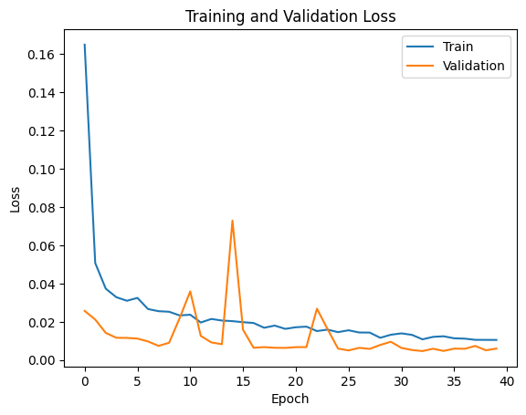

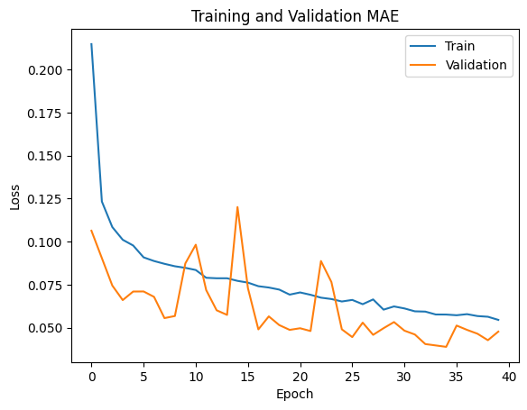

52/52 [==============================] - 0s 2ms/step

50/50 [==============================] - 0s 2ms/step

Validation RRMSE: 0.015191267208094066

Testing RRMSE: 0.061285408029906355

Final Evaluation on Test Data

52/52 [==============================] - 0s 2ms/step - loss: 0.0068 - mae: 0.0513

[0.006849454250186682, 0.051274623721838]

Loss:0.006849454250186682

MAE:0.051274623721838

**Iteration 5**

Metrics Averaged

===========================

Avg Loss: 0.024158240808174015

Avg Mae: 0.07516496125608682

Avg Val_Loss: 0.011105174053227529

Avg Val_Mae: 0.0580247638747096

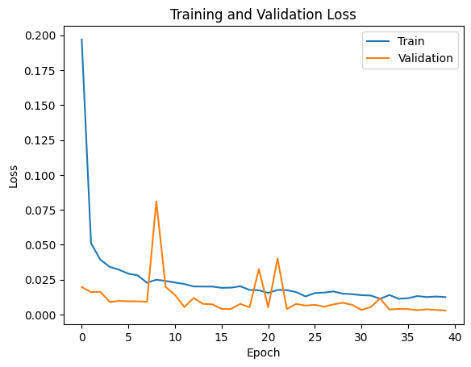

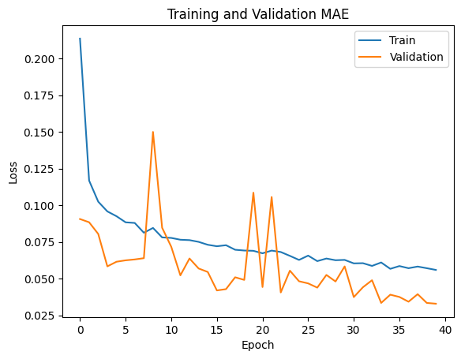

52/52 [==============================] - 0s 1ms/step

50/50 [==============================] - 0s 1ms/step

Validation RRMSE: 0.010646238929595122

Testing RRMSE: 0.04215273898783476

Final Evaluation on Test Data

52/52 [==============================] - 0s 1ms/step - loss: 0.0032 - mae: 0.0346

[0.0032403613440692425, 0.03457000479102135]

Loss:0.0032403613440692425

MAE:0.03457000479102135

**Iteration 6**

Metrics Averaged

===========================

Avg Loss: 0.02694685785099864

Avg Mae: 0.08143770629540086

Avg Val_Loss: 0.014013713324675336

Avg Val_Mae: 0.06456557381898165

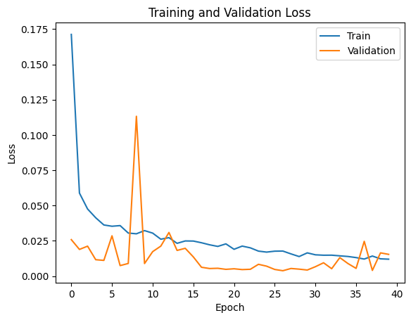

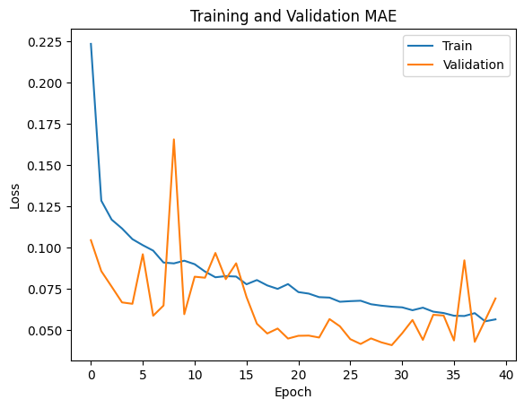

52/52 [==============================] - 0s 1ms/step

50/50 [==============================] - 0s 1ms/step

Validation RRMSE: 0.024331765357818082

Testing RRMSE: 0.08905734079692075

Final Evaluation on Test Data

52/52 [==============================] - 0s 1ms/step - loss: 0.0145 - mae: 0.0718

[0.014463761821389198, 0.07181650400161743]

Loss:0.014463761821389198

MAE:0.07181650400161743

**Iteration 7**

Metrics Averaged

===========================

Avg Loss: 0.022773605515249075

Avg Mae: 0.07441581944003701

Avg Val_Loss: 0.01273576997919008

Avg Val_Mae: 0.06203783303499222

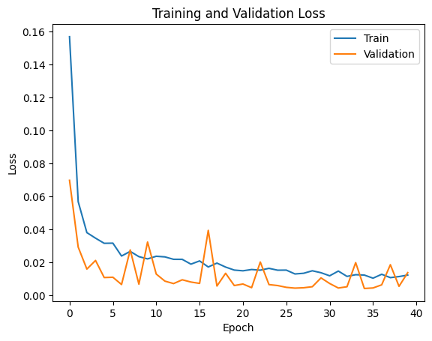

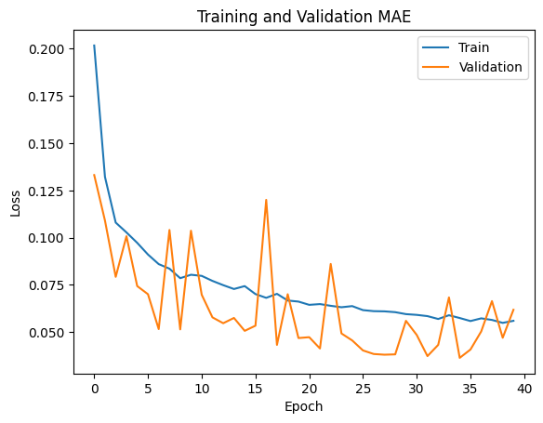

52/52 [==============================] - 0s 1ms/step

50/50 [==============================] - 0s 1ms/step

Validation RRMSE: 0.022948491734864254

Testing RRMSE: 0.09288330333645138

Final Evaluation on Test Data

52/52 [==============================] - 0s 1ms/step - loss: 0.0157 - mae: 0.0710

[0.015733202919363976, 0.07095666229724884]

Loss:0.015733202919363976

MAE:0.07095666229724884

**Iteration 8**

Metrics Averaged

===========================

Avg Loss: 0.022191140754148363

Avg Mae: 0.07329337196424604

Avg Val_Loss: 0.013446477998513728

Avg Val_Mae: 0.061518486589193344

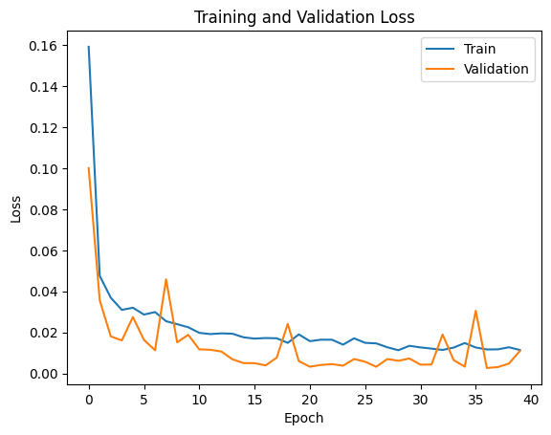

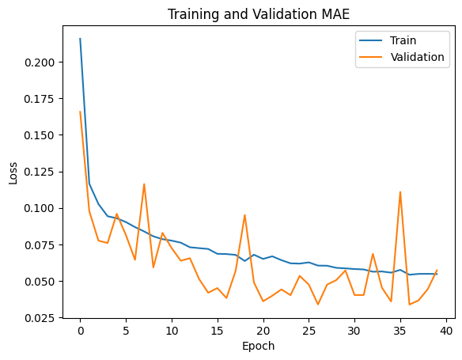

52/52 [==============================] - 0s 1ms/step

50/50 [==============================] - 0s 2ms/step

Validation RRMSE: 0.02056311543391373

Testing RRMSE: 0.07461028466810725

Final Evaluation on Test Data

52/52 [==============================] - 0s 2ms/step - loss: 0.0102 - mae: 0.0611

[0.010151710361242294, 0.06111440062522888]

Loss:0.010151710361242294

MAE:0.06111440062522888

**Iteration 9**

Metrics Averaged

===========================

Avg Loss: 0.02611302963923663

Avg Mae: 0.07999372715130448

Avg Val_Loss: 0.012725963001139462

Avg Val_Mae: 0.06434564590454102

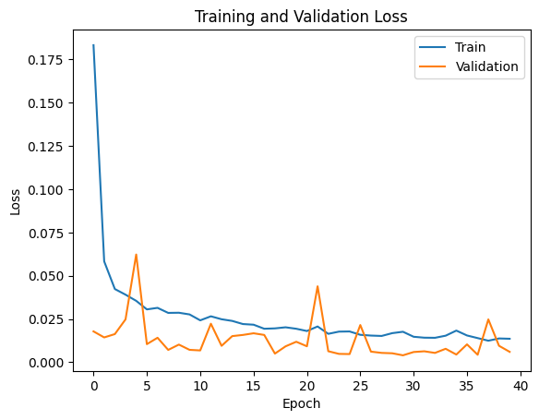

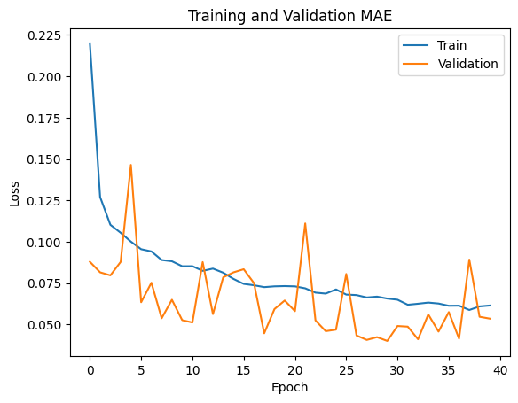

52/52 [==============================] - 0s 1ms/step

50/50 [==============================] - 0s 1ms/step

Validation RRMSE: 0.015216517696039645

Testing RRMSE: 0.04882123176962446

Final Evaluation on Test Data

52/52 [==============================] - 0s 2ms/step - loss: 0.0043 - mae: 0.0493

[0.004346695262938738, 0.049322664737701416]

Loss:0.004346695262938738

MAE:0.049322664737701416

**Iteration 10**

Metrics Averaged

===========================

Avg Loss: 0.021884362678974867

Avg Mae: 0.07529568448662757

Avg Val_Loss: 0.010978996218182147

Avg Val_Mae: 0.06084474502131343

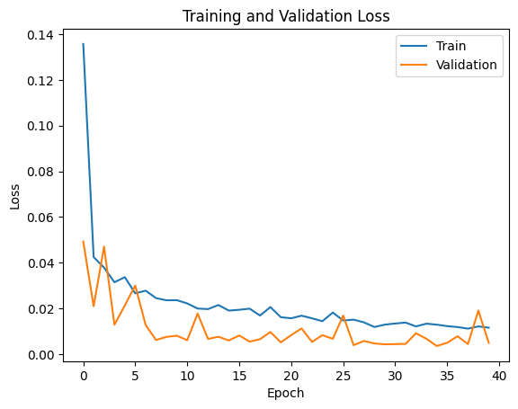

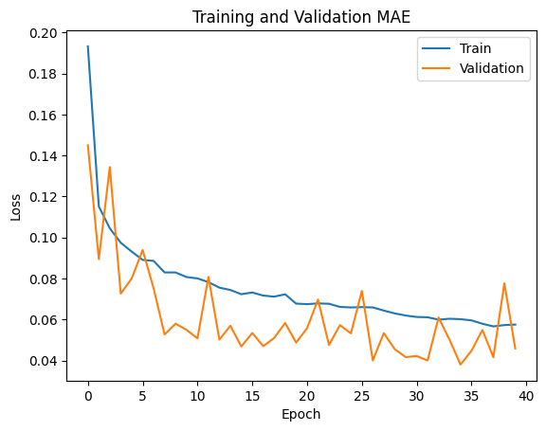

52/52 [==============================] - 0s 1ms/step

50/50 [==============================] - 0s 1ms/step

Validation RRMSE: 0.013721712220747275

Testing RRMSE: 0.05392540020342091

Final Evaluation on Test Data

52/52 [==============================] - 0s 2ms/step - loss: 0.0053 - mae: 0.0483

[0.005303084850311279, 0.04826241731643677]

Loss:0.005303084850311279

MAE:0.04826241731643677